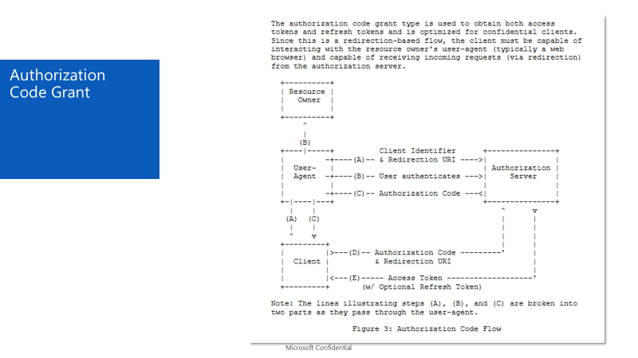

**From Fiddler Traces**

40 to 50 correspond to flow A and B

Line 64 has the flow step C notice element “code” on the response hidden input

Line 68 has flow D, notice grant_type=authorization_code and code sent along with redirect_uri. The response f line 68 has the bearer access token.

The access token is then used to request API resource (line E from the flow) notice security header on the request with bearer token.